Computer and Technology Meeting Tuesday, September 5th

Streaming TV
Streaming television is the digital distribution of television content, such as TV shows, as streaming media delivered over the Internet.
Streaming TV stands in contrast to dedicated terrestrial television delivered by over-the-air aerial systems, cable television, and/or satellite television systems.

Differences to Consider

Streaming | Dedicated
Use any device wired or wireless | Limited to HDMI wired devices with a special box
Use functionality of Smart TV | Smart TV disabled
Access from any location WorldWide | Access restricted to the wired location
Content commitments and choices flexible | Narrow selection of content - Long term commitments
NOTE: some of the cable services like Optimum also offer a Streaming TV service option.
What is a Roku box?
A Roku device acts like a computer by connecting to the Internet and into the TV’s HDMI port. It can be wired or wireless. It turns a dumb TV into a smart one. It uses it’s own remote control to provide the extra functionality.
With a Roku device you can mix and match all the streaming TV services available on the internet.

Getting started
Perform a search to identify available services. Go to the service of interest Website for details on cost and availability. Or you can browse the APPS available on your device or smart TV. After installing the APP of interest you will be directed to the service’s website to sign up. Then a key code can be obtained that will activate your device’s access to that service.
You can start either from the TV or from the internet. Most streaming services will grant you a 30 day free trial.

On a device go to the APP store and use the search function. On a smart TV look for a search box or symbol like a magnifying glass. Or start in Google – see the example below.
In this presentation I will review Youtube TV. Please note not to confuse the Youtube APP with the Youtube TV APP.

Google
Try the search “What to watch” include the quotes to force the search.

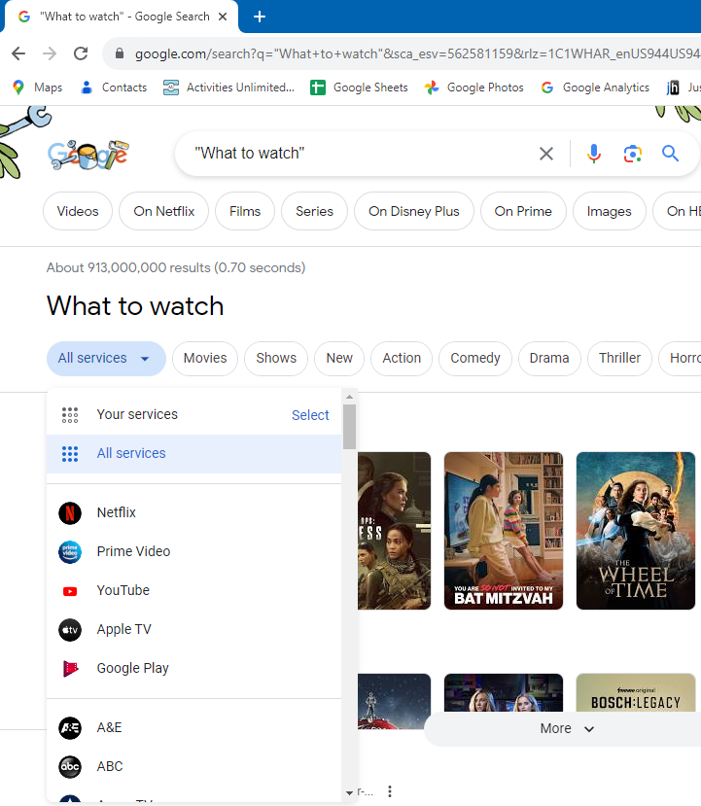
Click All services

Youtube TV
To visit their website for more information:
Click HERE > https://tv.youtube.com/welcome/

This is how it looks accessed via MS Edge on your Windows PC.
